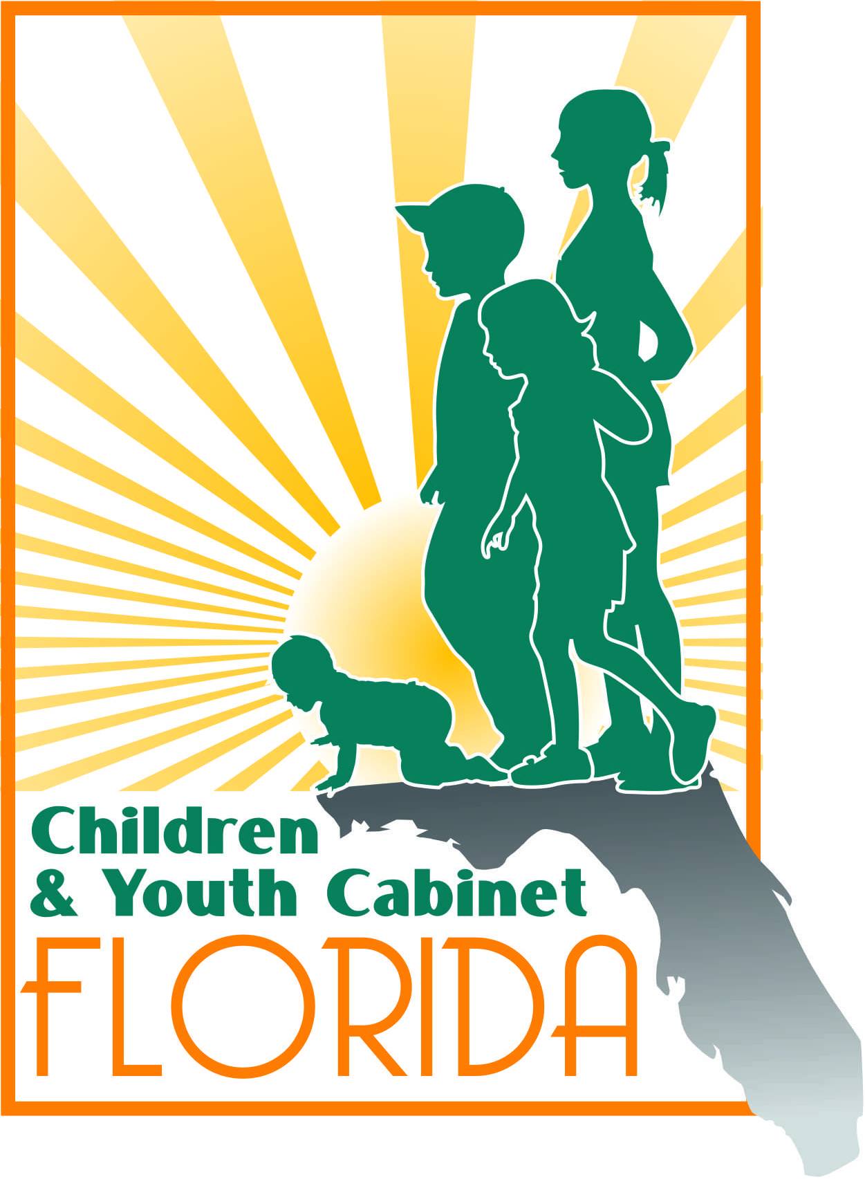
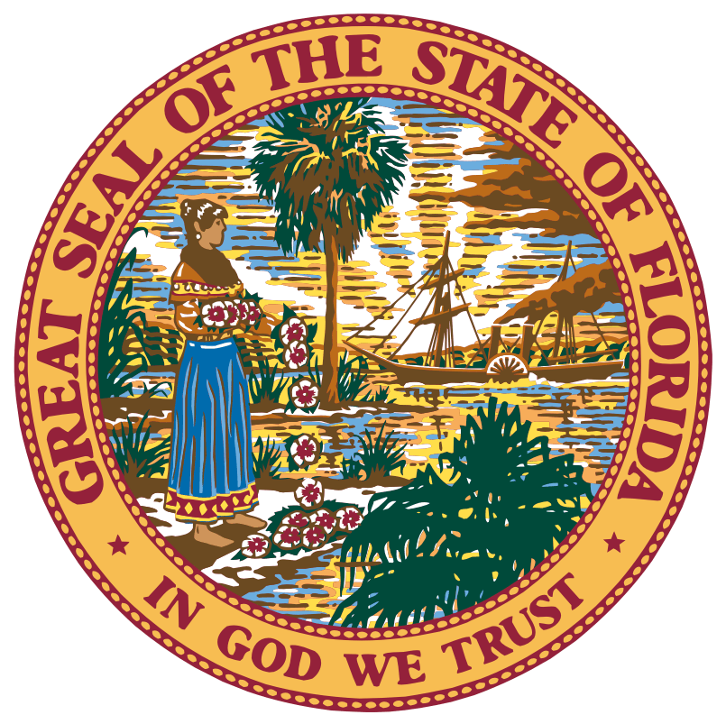
Florida Children and Youth Cabinet Meeting
January 22, 2018
1:00 p.m. – 4:00 p.m. EST
Florida Cabinet Meeting Room
The Capitol, Lower Level
400 S. Monroe Street, Tallahassee, FL 32399

Meeting Summary

Note: The following is a summary of the highlights of the proceedings and is not intended to be construed as a transcript. To obtain meeting materials, please visit www.flgov.com/childrens-cabinet.

Attendance Summary

FCYC members in attendance:

- Chair Wansley Walters
- Director Alan Abramowitz
- Secretary Mike Carroll
- Secretary Christy Daly
- Director Zackary Gibson
- Representative Gayle Harrell
- Superintendent Sam Himmel
- Judge Sandy Karlan (Ret.)
- Director Rodney MacKinnon
- Justice Barbara Pariente
- Director Barbara Palmer
- Dr. Celeste Philp
- Diana Ragbeer
- Secretary Justin Senior
- Steve Uhlfelder
- Victoria Vangalis Zepp

Member Representatives in Attendance:
- Jacob Oliva, for Commissioner Pam Stewart

Staff in Attendance:
- Lindsey Perkins Zander
- Brian Menard

Members, Member Representatives, and Guests on conference call:
Meeting Start: 1:05pm
Meeting End: 4:16pm
- Berthy de la Rosa-Aponte

Proceedings
Call to Order and Welcome
Chair Wansley Walters called the Florida Children and Youth Cabinet (Cabinet) meeting to order and welcomed Cabinet members.

The roll was called by Lindsey Zander and quorum was confirmed.

Opening – Human Trafficking in Florida
Chair Walters opened the meeting by discussing the Cabinet’s work in addressing Human Trafficking in Florida. Chair Walters informed attendees that the Statewide Council on Human Trafficking is housed within the Attorney General’s office, however, the issue—and sex trafficking in particular—remains a concern and priority of the Cabinet as it relates to youth and families. Chair Walters introduced attendees to Paul Coley, Founder and CEO of Scent Evidence K9.

Scent Evidence K9 with Special Guest, Elizabeth Smart
Paul Coley, a former FBI Forensic Canine Operations Specialist, has dedicated his entire career to public service in the fields of education, law enforcement, criminal justice, investigations, forensics, and emergency management. As a member of the FBI Evidence Response Team, he has deployed human scent evidence K9 Trailing teams in cases across the United States. He developed the first scientifically-tested and proven Scent Preservation Kit® to provide K9 Trailing responders with an uncontaminated scent article that can increase location success and reduce find time. Paul thanked the Cabinet for allowing him to speak and introduced them and attendees to Elizabeth Smart, recovery and abuse survivor, as well as Founder of the Elizabeth Smart Foundation.

Elizabeth Smart shared the story of her abduction and assault and thanked the Cabinet for hearing her story. Guardian ad Litem Executive Director Alan Abramowitz thanked the student participants of the Legislative Pages and Messenger programs for being in attendance to hear Elizabeth Smart’s powerful story. He acknowledged these youths as the future leaders we need and welcomed them to the Capitol. The other Cabinet members also thanked Elizabeth for sharing her story as an advocate and leader.

Paul Coley spoke more about Elizabeth Smart’s case. He described his company’s training team in Tennessee, a Scent Evidence team that is capable of tracking scents in missing child (persons) cases. He shared that the first three hours after a child goes missing is crucial time, however after those three hours pass, the chances decrease. Getting the right team in, with the right resources, is critical.

Agency for Persons with Disabilities Director Barbara Palmer mentioned that her group-homes could use the scent kits offered by Coley’s team. Coley shared that his team requires anyone that serves children to have some kind of certification as well because of how important the work is. He also mentioned that they are located in 30 states, eight countries, and several counties in Florida.

Department of Health Surgeon General Celeste Philip mentioned that this is valuable for children, but may also be valuable in serving older adults (i.e., with dementia). She asked about partner counties, to which Coley replied that they partner around the state and focus on at-risk, vulnerable populations.

Representative Ross Spano shared his proposed resolution on pornography as a public health issue. Representative Spano stressed the importance of his Resolution as an effort to start the conversation regarding pornography’s harmful effects and how it influences desensitization to sexual abuse, violence, and human trafficking. He emphasized that the resolution purely shares research findings. The Cabinet lauded Representative Spano for taking on awareness about pornography and its insidious effects and taking a leadership role on issues related to human trafficking. The question was raised as to whether the Cabinet could take action procedurally. It was noted that the Cabinet does not have a copy of the Resolution or have it on the agenda. Cabinet members thanked Representative Spano for speaking and resolved to review the resolution further.

Action Item #1: Send a copy of HR 157 - Public Health Risk Created by Pornography to Cabinet members for review.

Policy Impact Committee Recommendations: Voting on Legislative Initiatives
Sandy Karlan, Chair of the Policy Impact Committee (Committee), informed the Cabinet of the legislative recommendations that the Committee has brought to the Cabinet for support. Chair Karlan reviewed each of the Legislative Budget Requests (LBR), as well as policy requests, proposed by each Cabinet agency. The Cabinet agency leaders then provided further context and clarification on each legislative initiative.

Representative Gayle Harrell shared her legislative initiatives currently in committee. She informed the Cabinet that Florida has had a Title IV-E waiver since 2007 (set to expire in 2019) that allows Florida to function as a block grant state to use creative processes that allows more children to remain at home. Representative Harrell will be discussing the bill in committee, in addition to the HM 817—Renewal of Title IV-E Waivers for Child Welfare Services. Representative Harrell also informed the Cabinet of HB 21, Controlled Substances by Representative Boyd, which addresses the opioid epidemic. The PCB for the Title IV-E waiver will be introduced in committee on January 23, 2018.

Department of Children and Families (DCF) Secretary Mike Carroll noted that it is important to remember that the Cabinet can support the original intent, or principle, of the bill—but the language may change throughout the legislative process due to amendment changes. It is important to be aware of language changes that reflect details that the Cabinet does not agree with.

Task Force on Involuntary Examinations of Minors
DCF Assistant Secretary John Bryant presented the Cabinet with recommendations from the Task Force on Involuntary Examinations of Minors report. No single root cause was found to explain the increase in Baker Acts. The Task Force found that prevention and early intervention initiatives were critical in reducing the number of Baker Acts. Thirty to thirty-five percent of Baker Acts were found to be unnecessary, however, no other local resource was available to serve as a risk assessment.

Representative Harrell has reviewed the Task Force’s report, and will be following up on it with legislation.

Justice Pariente asked if there has been misuse of the Baker Act to reduce the number of in-school and out-of-school suspensions. Assistant Secretary Bryant said this topic was discussed and in part the community doesn’t know what the less restrictive options to Baker Act are and there is a need for more training. There are school districts that have limited options for intervening without resorting to Baker Acts. Getting SEDNET involved helped reduce admissions in some of the larger school districts. Superintendent of Citrus County Sam Himmel recounted that her district has a crisis team in each school and still has Baker Acts. She cautioned the Cabinet in its use of the word “abuse” of Baker Acts.

Secretary Carroll of DCF challenged the Cabinet to consider robust, wraparound services that can follow individuals through care to ensure that they are successful. Otherwise, he warned the Cabinet that the kids they cannot provide this type of service to will be the same youth they see repeatedly.

Advocacy Groups
Office of Early Learning (OEL) Director Rodney MacKinnon noted that the T.E.A.C.H. Early Childhood Florida and Help Me Grow legislative initiatives aligned with OEL’s LBR and that they do not need to be excluded from the Cabinet’s vote. Chair Walters recommended that they be voted on for support in the programmatic category, as opposed to the department LBR category.

Florida State University Center for Prevention and Early Intervention Policy Director Dr. Mimi Graham provided a presentation to the Cabinet on the First 1000 Days initiative. Dr. Graham provided four policy recommendations for the Cabinet to support.

Florida Association of Healthy Start Coalitions Executive Director Jim Bracher informed the Cabinet of the 32 Healthy Start coalitions around the state. Director Bracher informed the Cabinet that the program began in 1992 and now has 1000 workers around the state serving pregnant women and infants.

Department of Health (DOH) Dr. Celeste Philip presented on behalf of the Children’s Forum’s T.E.A.C.H. Early Childhood Florida program.

Tamara Price with Help Me Grow (HMG) informed the Cabinet of its goal to connect youth with developmental delays to supportive resources. HMG now has partners in 29 counties and has requested for additional resources to continue expanding services across Florida. Since implementation of the program, HMG has screened 3,356 individual children in Florida. They have also provided over 4,000 referrals to programs. Agency for Health Care Administration Secretary Justin Senior offered his support should HMG have any trouble in the future working with Medicaid to serve the percent of Medicaid covered families that HMG serves.

Diana Ragbeer presented on behalf of Early Steps for $2M to address the increase in families now eligible because of expanded access criteria. The opioid crisis has made this more urgent as has influx from Puerto Rico.

The Cabinet will not be able to support advocate legislative requests because their requests are not in the agency’s LBRs. The Cabinet voted to approve in concept all of the requests of the Departments. The Cabinet will also be able to support the work and would encourage careful review and consideration of the report and the recommendations made by the Task Force on Involuntary Examinations of Minors.

Action Item #2: Lindsey will share Task Force on Involuntary Examinations of Minors report’s executive summary and recommendations.

Memorandum of Understanding Update
Governor’s Office of Adoption and Child Protection Director Zackary Gibson informed the Cabinet that the agreement has officially been signed by each Cabinet agency. Director Gibson stated that he believes the agreement allows the Cabinet to look at youth who are served by multiple agencies, but moreover, it allows the Cabinet to effectively serve at-risk youth. The agreement provides a framework to serve children existing within symptoms of care, or close to entering them. The agreement will be in effect through 2022.

Technology Workgroup Update
Workgroup Chair Victoria Zepp provided updates regarding the workgroups progress. She will be attending the Winter Innovation Summit in Utah, hosted by the Sorenson Impact Center, to present on the Cabinet’s P3 grant in Broward County. Chair Zepp also informed the Cabinet of the Agency for State Technology’s new Chief Data Officer, Burt Walsh, and his role as a future partner of the Technology Workgroup.

Representative Harrell noted that the legislature is committed to making data systems work; there are huge resources being spent and there have to be interoperability of systems across the executive agencies. She recommends there be a standing IT committee under the auspices of the Cabinet to ensure the interoperability of systems.

Action Item #3: Lindsey will share the list of Workgroup liaisons with each Cabinet member.

Public Comment
A motion was passed to extend the meeting 15 minutes to allow FSU College of Medicine’s Les Beitsch, M.D., J.D. to speak. Dr. Beitsch informed the Cabinet of proposed Constitutional Amendment 94 to the Florida Education and Prevention Act which governs the Tobacco settlement dollars. The proposed amendment would divert dollars from tobacco settlement program from prevention to research. The Constitutional amendment would remove specific percentages and allow for more flexibility in the allocating proportions. There will be 5-7 public hearings before final changes in May 2018. Surgeon General Philip commented on DOH efforts to meet with Commissioner Jeanette Nuñez, who is sponsoring the proposal, in order to address public health concerns.

Closing
The next Children and Youth Cabinet Meeting will tentatively take place in April, in Jacksonville or Pensacola, Florida.

Adjournment
Chair Walters adjourned the Florida Children and Youth Cabinet meeting at 4:16 p.m.

